MultiICE Application Note

Version 1.0

SHMT Co., Ltd.

REVISION HISTORY
Version | Detail(굴림/Verdana 10pt bold) | Name | Date
1.0 | First Version | gtlee | 2007-06-11

Technical documents
Copyright © 2006 Shmt Limited. All rights reserved.
Referenced ARM9EJ-S Technical Reference Manual

Confidentiality Status
This document is NOT OPEN ACCESS. The distribution is restricted to certified company.
This document is CONFIDENTIAL.

Feedback on this document
If you have any comments on this document, please contact your channel to our company.

Shmt Web address
http://www.shmt.com

Contents

1. Validation Resource 7
1.1. Base Information 7
1.1.1. Base Directory 7
1.1.2. Tools 7
1.2. RTL Sources 7
1.2.1. ARM926EJ-S top files 7
1.2.2. Test Bench files 8
1.3. RTL compile 8
1.3.1. Directory 선택 8
1.3.2. Platform 선택 8
1.3.3. Compile 9
1.4. Validation 9
1.4.1. Configuration File 수정 9
1.4.2. RTL Directory Link 11
1.4.3. Create Job scripts 11
1.4.4. Execution Job script 11

Figures

오류! 그림 목차 항목을 찾을 수 없습니다.

Tables

Table 1-1 libraries.vc 예제 7

MultiICE

MultiICE pin connections

Figure 1-1 MultiICE pin connections
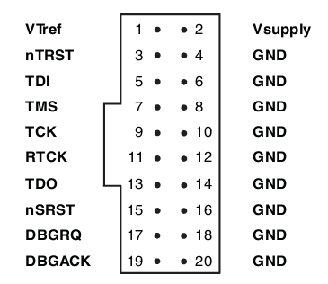

Signals

Table 1-1 MultiICE signals
Signal Name | I/O | Description
VTref | I | Target reference voltage.  RTCK와 TDO의 logic-level의 기준 전압을 알려준다.
Vsupply | I | MultiICE의 target보드쪽에서의 공급 전원.
nTRST | O | JTAG reset
TDI | O | JTAG data output to target cpu
TMS | O | JTAG test mode signal
TCK | O | JTAG JTAG test clock
RTCK | I | Return test clock
TDO | I | JTAG data input from target cpu
nSRST | I/O | All system is reset.  이 신호는 option으로 사용비중은 높으나 필수 신호는 아니다.
DBGRQ | O | Debug request. Not used in the MultiICE.
DBGACK | I | Debug acknowledge. Not used in the MultiICE.

Schematic

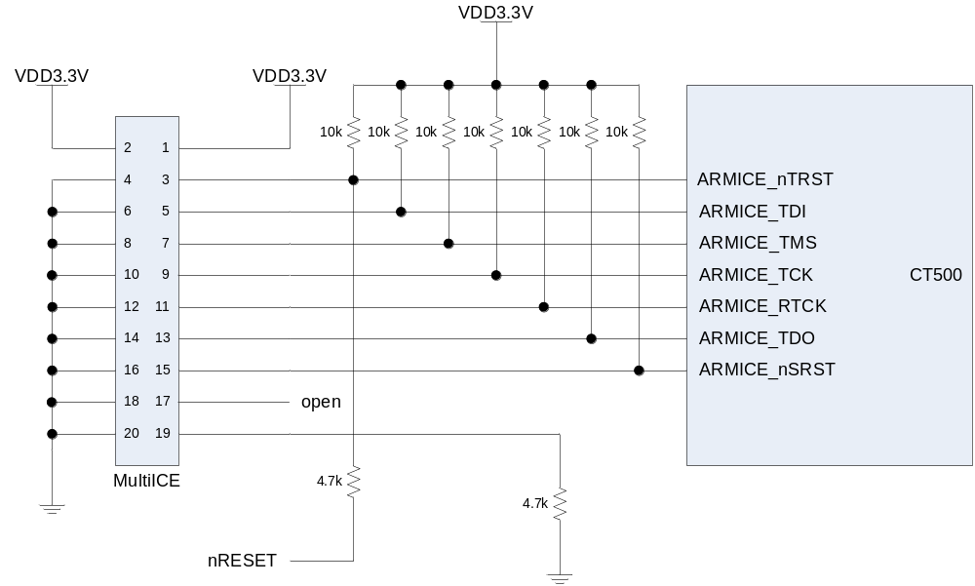

- CT500의 IO전압이 3.3V이므로 Vsupply와 VTref에 3.3V를 공급한다.
- nRESET은 system reset으로 CT500이 reset될 때 JTAG control block도 reset시킨다.
- DBGRQ와 DBACK는 ARM MultiICE에서는 사용하지 않으므로 입력신호만 pulldown시킨다.

